Brett Stelly

July 9, 2018

Cross-platform Development

**Data Persistence Demonstration**

**Saving an Inventory:**

The player inventory can be saved at any time. When the inventory is saved, a “save.json” file will appear in the following directory:

C:\Users\username\AppData\LocalLow\BrettCo\CrossPlatformDevelopment\save.json

**Overwriting a Save:**

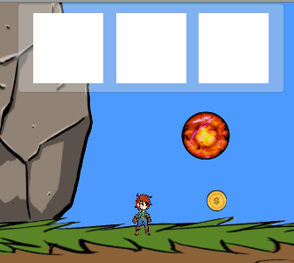Saving when there is already a save file will overwrite the current save with the updated inventory data.



Saving

Current Save New Save

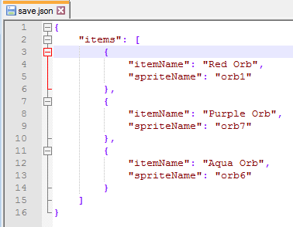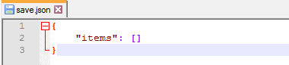

**Loading a Save:**

A save file can be loaded at any time, but if a save file does not exist, nothing will happen. If a previous save does exist, the player’s inventory will be overwritten with the data contained within the save file.

For example:

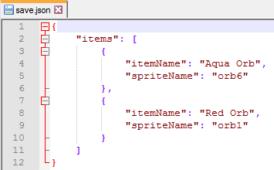

This is the current save file

Launch the application. The inventory should be empty.

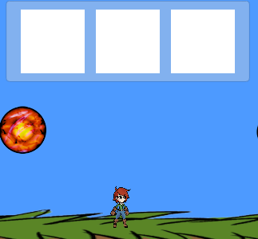

Load the current save and the inventory should now look like this.

